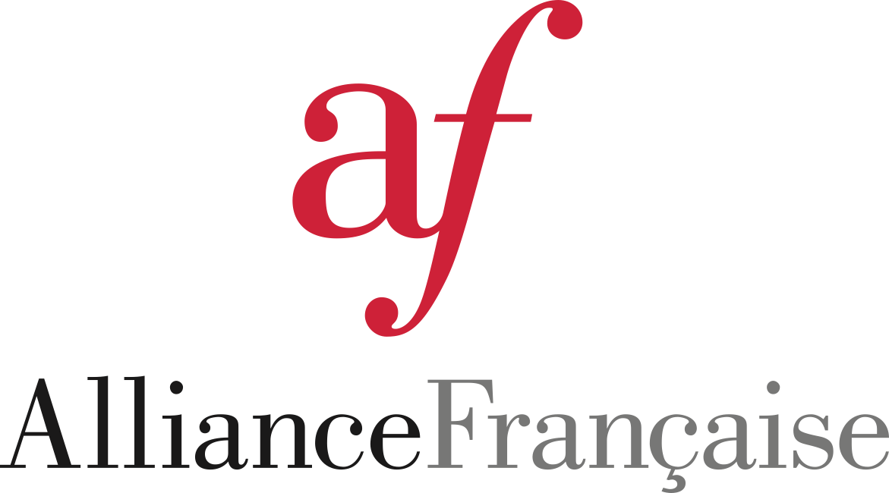

Alliance Française Doylestown & Bucks County
PO Box 1292, Doylestown, PA 18901

Membership Dues through August 31, 2027

Annual Dues:
Age 18-59 ($50)_________
60+ ($40)_________
Couple ($60)_________
Full-time student over 18 ($25)_________
High School Student free of charge

To join, please send a check payable to Alliance Française Doylestown. Mail to PO Box 1292, Doylestown, PA 18901.

Please include your name, address, telephone number and email address even if you are a returning member.

Name(s)_____________________________________________________

Address:____________________________________________________

Phone:_____________________________________________________

email:______________________________________________________

May we include your contact information in our annual member directory (distributed only within our Alliance chapter)?
Yes____________ No______________

Annual Fund Donation

YES, I would like to support the Alliance Française programs and other chapter community initiatives.

Enclosed is my donation:

_________$25 ___________$50 ________$100 _____$250 _____$500

_________ Other amount ( please specify)

